Social Engineering Awareness Guide
Cyber Security Track · Task 6 · Prepared by Amruta
1. Introduction
Social engineering is the practice of manipulating people into giving away confidential information or performing actions that help an attacker. Instead of breaking into a system with technical tricks, the attacker targets the human, who is often the easiest part of security to fool. This guide explains common social engineering scenarios, the warning signs to look for, and the steps employees can take to stay safe.
2. Why Social Engineering Works
Attackers take advantage of normal human behavior:
- Trust: people tend to believe someone who sounds friendly or professional.
- Authority: people follow requests that seem to come from a manager, the IT team, a bank or the government.
- Urgency and fear: pressure such as "your account will be blocked" stops people from thinking clearly.
- Helpfulness: people like to help, so they share information or hold a door open.
- Curiosity and greed: free offers, prizes and interesting files tempt people to click.
3. Common Social Engineering Scenarios
Attack | How it works | Example
Phishing | Fake emails or websites that look genuine are used to steal data. | An email says "verify your password now" with a fake login link.
Vishing (voice phishing) | The attacker calls and pretends to be a bank or IT support. | A caller asks for an OTP to "stop a fraud".
Smishing (SMS phishing) | Text messages carry malicious links. | "Your parcel is held, pay a small fee" with a link.
Pretexting | The attacker invents a believable story to gain trust and then asks for information. | A fake "IT helpdesk" caller asks for your password to fix your laptop.
Impersonation / CEO fraud | The attacker pretends to be a senior manager, vendor or colleague. | A fake "director" email asks the accounts team to urgently transfer money.
Baiting | The attacker leaves an infected device or offers a free download. | A USB drive labelled "Salary List" is left in the parking area.
Tailgating | The attacker follows an authorized person into a restricted area. | A stranger carrying boxes asks you to hold the door.
Quid pro quo | The attacker offers a service or gift in return for information. | "Free tech support" if you turn off your antivirus.
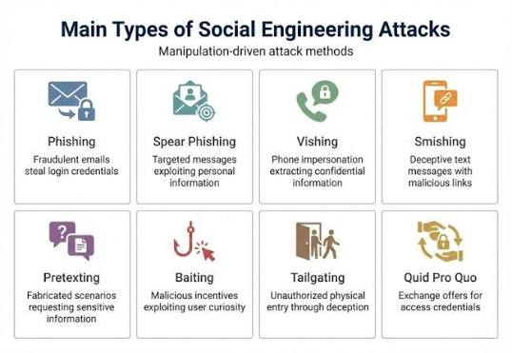
4. Warning Signs
Urgency
- Messages that demand immediate action, with deadlines such as "within 1 hour".
- Threats of account suspension, legal action or penalty.
- Pressure not to tell anyone or not to check with anybody else.
Impersonation
- The sender's email address or phone number is slightly different from the real one.
- The person claims to be from IT, HR, a bank, a courier or senior management but cannot be verified.
- Unexpected contact from someone who normally would not contact you.
Suspicious Requests
- Asking for passwords, OTPs, PINs or card details (genuine organizations never ask for these).
- Asking you to install software, open an unexpected attachment or click a shortened link.
- Asking for a money transfer, gift cards or a change of bank details.
- Asking you to skip the normal process or approval.
- Generic greetings, spelling mistakes or an unusual tone.

5. Example Scenarios
Scenario 1: Fake IT support call. A caller says, "I am from IT, your system has a virus, tell me your password so I can fix it."
- Warning signs: unexpected call, urgency, request for a password.
- Correct action: refuse, hang up and call the IT helpdesk on the official number.
Scenario 2: CEO fraud email. An email that looks like it is from the director asks the accounts team to urgently pay a new vendor and keep it confidential.
- Warning signs: urgency, secrecy, unusual payment request, sender address slightly different.
- Correct action: verify by phone or another known channel and follow the normal approval process.
Scenario 3: Prize SMS. A message says you have won a gift and must click a link and enter bank details.
- Warning signs: too good to be true, unknown sender, suspicious link.
- Correct action: do not click, delete the message and report it.

6. How Employees Can Prevent Social Engineering
- Stop and think before reacting to an urgent message or call.
- Verify the identity of the person through an official channel.
- Never share passwords, OTPs or PINs with anyone, not even someone claiming to be from IT.
- Check the sender address, hover over links and do not open unexpected attachments.
- Use strong, unique passwords and turn on multi-factor authentication.
- Do not plug in unknown USB drives.
- Do not hold doors for unknown people. Ask for an ID badge and make sure visitors are escorted.
- Be careful about what you share on social media, such as job role, colleagues and travel plans.
- Keep the operating system, browser and antivirus updated.
- Report suspicious emails, calls or messages to the IT or security team right away.
7. What to Do If You Think You Have Been Targeted
- Stop communicating with the sender or caller.
- Do not click any more links or open attachments.
- If you already shared a password, change it immediately from a safe device.
- Report it to the IT or security team and your manager. Inform your bank if money or card details are involved.
- Note the details (time, phone number, email address) to help the investigation.
8. Interview Questions
What is social engineering? Social engineering is a cyber attack that targets people instead of systems. The attacker tricks the victim into revealing confidential information or taking an action, such as clicking a link or sharing a password, by using trust, fear or urgency.
What is pretexting? Pretexting is a social engineering technique in which the attacker creates a believable made-up story (a pretext) and pretends to be someone trusted, such as IT support, a bank officer or a vendor, to get information or access from the victim.
How can employees prevent social engineering? Employees can prevent it by staying alert to urgent or unusual requests, verifying identities through official channels, never sharing passwords or OTPs, avoiding unknown links, attachments and USB drives, using multi-factor authentication, and reporting suspicious activity to the security team immediately. Regular awareness training also helps.
9. Conclusion
Social engineering succeeds because attackers target human behavior rather than technology. By learning the common scenarios, recognizing warning signs such as urgency, impersonation and suspicious requests, and following simple safety habits, employees can become a strong line of defense for their organization.

